SSH Key credential
# Source: AI Source: Provided by: [Data Path: Persons Table -> ID Column: 1, Name_En Column: Motasem Essam] -> From: [ChatGPT] on [1/18/2026]
An SSH Key credential is a cryptographic authentication method used to securely log into servers and systems without using a password.

🔐 What is an SSH Key?
# Source: AI Source: Provided by: [Data Path: Persons Table -> ID Column: 1, Name_En Column: Motasem Essam] -> From: [ChatGPT] on [1/18/2026]
An SSH key is a pair of keys:
- 🔑 Private key → kept secret on your machine
- 🗝️ Public key → stored on the server
Example
Private key: id_rsa
Public key: id_rsa.pub

🛠️ How it works
# Source: AI Source: Provided by: [Data Path: Persons Table -> ID Column: 1, Name_En Column: Motasem Essam] -> From: [ChatGPT] on [1/18/2026]
- You try to connect to a server via SSH
- Server sends a challenge
- Your private key signs the challenge
- Server verifies it using your public key
- If it matches → access granted
👉 The private key never leaves your device

🖥️ SSH login process Example
# Source: AI Source: Provided by: [Data Path: Persons Table -> ID Column: 1, Name_En Column: Motasem Essam] -> From: [ChatGPT] on [1/18/2026]
Got it! Let’s break this SSH login process step by step in a very clear way, without skipping anything, so it makes sense. I’ll also explain where the keys come from and how the challenge works.

SSH Login Process (Step by Step)

Step 0: Generate SSH Keys
# Source: AI Source: Provided by: [Data Path: Persons Table -> ID Column: 1, Name_En Column: Motasem Essam] -> From: [ChatGPT] on [1/18/2026]
- You generate a key pair on your computer using a command like:
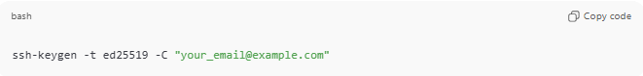
ssh-keygen -t ed25519 -C "your_email@example.com"
What happens:
- ssh-keygen → program on your computer that creates secure SSH keys
- -t ed25519 → type of key (modern, secure algorithm)
- -C → optional label to identify the key

Keys generated:
- Private key → stays on your computer (~/.ssh/id_ed25519) → never shared
- Public key → safe to share (~/.ssh/id_ed25519.pub) → copy to server
Important: You don’t type these keys yourself — they are long, random, and computer-generated.

Step 1: Copy Public Key to Server
# Source: AI Source: Provided by: [Data Path: Persons Table -> ID Column: 1, Name_En Column: Motasem Essam] -> From: [ChatGPT] on [1/18/2026]
- You copy your public key to the server:
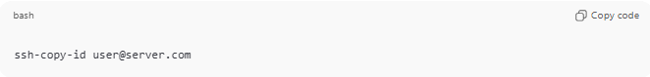
ssh-copy-id user@server.com
Breakdown:
- user → your username on the server
- server.com → server’s IP address or hostname
What happens:
- Server stores the public key in:
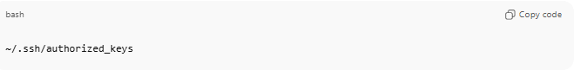
~/.ssh/authorized_keys

- This file contains the public keys that the server has already approved for your account.
Example:
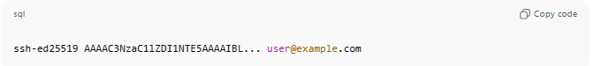
ssh-ed25519 AAAAC3NzaC1lZDI1NTE5AAAAIBL... user@example.com
- Each line = one trusted public key This has three parts:
- Key type → ssh-ed25519
  - Specifies the algorithm of the key (modern and secure).
- Public key data → AAAAC3NzaC1lZDI1NTE5AAAAIBL...
  - This is the actual public key — the unique string that the server uses to verify signatures.
  - This part is what actually matters for authentication.
- Comment / label → user@example.com
  - This is optional.
  - It’s just a name or email to help identify the key.
  - You could write your email, your username, or any text like My Laptop Key.
  - It does NOT affect authentication.

- The server does not trust every public key, only the ones in this file.
- The server now knows: “If someone can sign a message using the matching private key, allow access.”

Step 2: Initiate SSH Connection
# Source: AI Source: Provided by: [Data Path: Persons Table -> ID Column: 1, Name_En Column: Motasem Essam] -> From: [ChatGPT] on [1/18/2026]
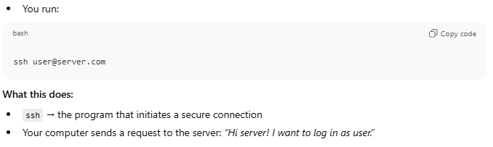
- You run:
ssh user@server.com
What this does:
- ssh → the program that initiates a secure connection
- Your computer sends a request to the server: “Hi server! I want to log in as user.”

Step 3: Server Sends a Challenge
# Source: AI Source: Provided by: [Data Path: Persons Table -> ID Column: 1, Name_En Column: Motasem Essam] -> From: [ChatGPT] on [1/18/2026]
- The challenge is a random piece of data (basically a “puzzle”) generated by the server to prove you own the private key.
- Purpose: Prove that the client owns the private key without sending the key itself.
Example of a challenge (simplified):
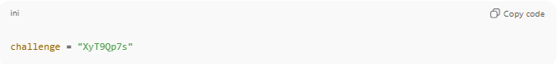
challenge = "XyT9Qp7s"
- This string is generated fresh every time you log in.
Important details about the challenge:
- It is different every time you try to log in
- It cannot be reused by attackers
- Think of it like the server saying: “Prove you are really you without sending me a password!”
Analogy:
- Server says: “Sign this form to prove you are really you.”
- Your private key acts like your personal stamp; signing the challenge is like stamping the form.
- The server checks the stamp against the public key on file.

Step 4: Client Signs the Challenge
# Source: AI Source: Provided by: [Data Path: Persons Table -> ID Column: 1, Name_En Column: Motasem Essam] -> From: [ChatGPT] on [1/18/2026]
- Your computer uses your private key to sign the challenge.
Private key location:
- ~/.ssh/id_ed25519 (or id_rsa) on your local machine
Signing:
- The private key creates a signature from the challenge (The SSH program takes the challenge and your private key and runs a cryptographic algorithm that produces a signature.)
Important:
  - You never type the key or the signature manually.
  - The private key never leaves your computer.

Conceptual example:
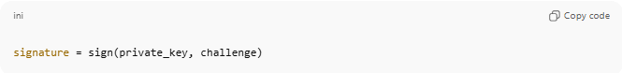
signature = sign(private_key, challenge)

- This signature proves ownership of the private key without sending the key itself
Analogy:
- Signing = putting your unique digital stamp on the server’s “form”

Step 5: Server Verifies Signature
# Source: AI Source: Provided by: [Data Path: Persons Table -> ID Column: 1, Name_En Column: Motasem Essam] -> From: [ChatGPT] on [1/18/2026]
- The server uses your public key (from authorized_keys) to verify the signature.
If it matches:
- Server knows you have the private key
- Authentication succeeds
Important:
- Only the signed challenge is sent over the internet
- The private key never leaves your computer

🔑 How the server verifies the signature
- Server receives the signature
- The client sends back the signature (not the private key, only the signed data).
- Server uses the public key
- The server has your public key stored in ~/.ssh/authorized_keys.
- It runs a cryptographic verification algorithm:
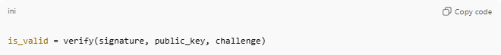
is_valid = verify(signature, public_key, challenge)
- What verification does
- It checks: “Could this signature have been produced using the private key that matches this public key?”
- If yes → login succeeds
- If no → login denied

Why this works
- The signature is unique to both the challenge and the private key.
- The public key cannot generate the signature, but it can verify it.
- The private key never leaves the client — only the signature is sent.
- Replay attacks are prevented because the challenge changes every time.

Analogy:
- Challenge = blank form
- Private key = your personal stamp
- Signature = stamped form sent back
- Public key = stamp on file at server
- Server checks if stamp matches → confirms it’s you

Step 6: Access Granted
# Source: AI Source: Provided by: [Data Path: Persons Table -> ID Column: 1, Name_En Column: Motasem Essam] -> From: [ChatGPT] on [1/18/2026]
- Server opens a secure session
- You can now work on the server
- All communication is encrypted
- Private key stays on your computer; public key stays on server

🔑 Key Locations and Roles
# Source: AI Source: Provided by: [Data Path: Persons Table -> ID Column: 1, Name_En Column: Motasem Essam] -> From: [ChatGPT] on [1/18/2026]
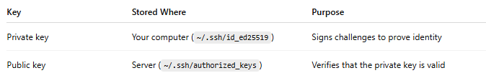
Key | Stored Where | Purpose
Private key | Your computer (~/.ssh/id_ed25519) | Signs challenges to prove identity
Public key | Server (~/.ssh/authorized_keys) | Verifies that the private key is valid

🔒 Real-World Analogy
# Source: AI Source: Provided by: [Data Path: Persons Table -> ID Column: 1, Name_En Column: Motasem Essam] -> From: [ChatGPT] on [1/18/2026]
- Private key → your personal signature
- Public key → signature on file at a trusted office
- Server challenge → the form you must sign
- Signing it proves you are you without giving away the signature itself

✅ Key Points
# Source: AI Source: Provided by: [Data Path: Persons Table -> ID Column: 1, Name_En Column: Motasem Essam] -> From: [ChatGPT] on [1/18/2026]
- Private key is never transmitted
- Public key is shared safely with server
- Challenge = random, unique each login, prevents replay attacks
- Signing = proves ownership of private key
- Computer generates keys; you don’t type them

📍 Where it’s used
# Source: AI Source: Provided by: [Data Path: Persons Table -> ID Column: 1, Name_En Column: Motasem Essam] -> From: [ChatGPT] on [1/18/2026]
- Linux/Unix servers
- Cloud VMs (AWS, Azure, GCP)
- Git servers (GitHub, GitLab)
- DevOps & automation
- Remote administration

🧬 Types of SSH keys
# Source: AI Source: Provided by: [Data Path: Persons Table -> ID Column: 1, Name_En Column: Motasem Essam] -> From: [ChatGPT] on [1/18/2026]
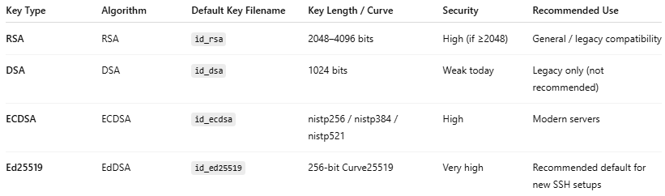
Key Type | Algorithm | Default Key Filename | Key Length / Curve | Security | Recommended Use
RSA | RSA | id_rsa | 2048–4096 bits | High (if ≥2048) | General / legacy compatibility
DSA | DSA | id_dsa | 1024 bits | Weak today | Legacy only (not recommended)
ECDSA | ECDSA | id_ecdsa | nistp256 / nistp384 / nistp521 | High | Modern servers
Ed25519 | EdDSA | id_ed25519 | 256-bit Curve25519 | Very high | Recommended default for new SSH setups

✅ Advantages
# Source: AI Source: Provided by: [Data Path: Persons Table -> ID Column: 1, Name_En Column: Motasem Essam] -> From: [ChatGPT] on [1/18/2026]
- Much more secure than passwords
- Resistant to brute-force attacks
- Automation-friendly
- No password transmission

⚠️ Disadvantages
# Source: AI Source: Provided by: [Data Path: Persons Table -> ID Column: 1, Name_En Column: Motasem Essam] -> From: [ChatGPT] on [1/18/2026]
- Private key must be protected
- Key loss = lost access
- Poor key management can be risky

🔒 Best practices
# Source: AI Source: Provided by: [Data Path: Persons Table -> ID Column: 1, Name_En Column: Motasem Essam] -> From: [ChatGPT] on [1/18/2026]
- Use ED25519 keys
- Protect private keys with a passphrase
- Never share private keys
- Restrict access in authorized_keys
- Rotate keys periodically
- Disable password login on servers

🧠 Authentication factor
# Source: AI Source: Provided by: [Data Path: Persons Table -> ID Column: 1, Name_En Column: Motasem Essam] -> From: [ChatGPT] on [1/18/2026]
- Something you have → private key
- Something you know → passphrase (optional)

🧨 Common mistakes
# Source: AI Source: Provided by: [Data Path: Persons Table -> ID Column: 1, Name_En Column: Motasem Essam] -> From: [ChatGPT] on [1/18/2026]
- Committing private keys to Git
- Using weak RSA key sizes
- Sharing keys across multiple users
- Leaving old keys on servers

